Diskographie:
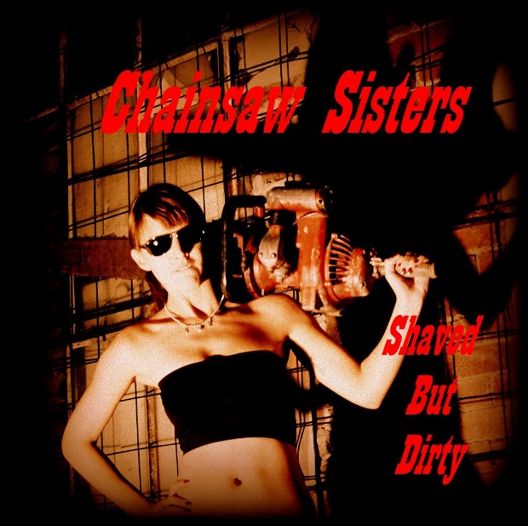
Shaved But Dirty – EP (2014)
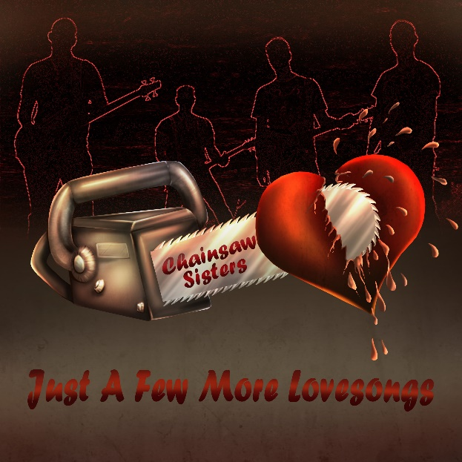
Just A Few More Lovesongs – LP (2018)
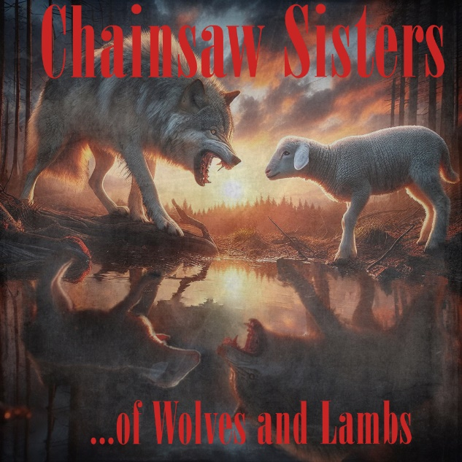
Of Wolves & Lambs – EP (2024)

